4COSC006C.2

Coursework : Individual Course Work Report

Group No: 6

IIT Student No - 20242094
UOW Student No – W2153607
Name with Initials – Amoda Weerakoon

Tutorial Lecturer : Mr.Guhanathan Poravi
Module Leader : Mr.Guhanathan Poravi

School of Computing
Informatics Institute of Technology (IIT Campus)

1.Introduction

This document details the step-by-step processes involved in designing and developing a Python Task Manager Application which was completed in two key milestones:
- Stage 3 adds a command-line interface for task handling where tasks are stored in JSON files and managed with commands.
- Stage 4 further implements a graphical user interface with Tkinter, enabling dynamic filtering and sorting of tasks as they are viewed.
Some of the core functionalities include reading and writing files, validating user inputs, and employing classes and objects. In doing so, the Task Manager becomes simpler and easier to use for tracking tasks.

2.Code Explanation For Stage 3 – JSON File Handling
The application changed from using simple task lists to a more structured format with dictionaries and JSON-based persistent storage in Stage 3.
The following keys are used to store each task as a dictionary:
Name, description, and priority
The due date
Important Features Added:
• Input Validation: "High," "Medium," or "Low" are the validated task priorities.
- The due date is manually verified to adhere to the YYYY-MM-DD format, which includes checking for leap years.
• JSON File Operations: At startup, the function load_tasks_from_file() loads tasks from a JSON file.
The current task list is written back to the file by the save_tasks_to_file() function.
• CRUD Operations: - From the terminal, users can add, view, update, and delete tasks.
Tasks are saved following each change.
• Error Handling: In the event that a file is missing or contains errors, a fresh JSON file is

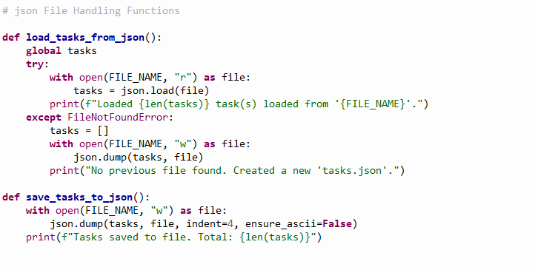

3.Code Explanation For Stage 4 – Tkinter GUI for Task Management
In stage four, Tkinter was used to create an intuitive graphical user interface.
Principal Elements:
• Task Class: Contains a method to convert objects to dictionaries for JSON saving and represents distinct tasks.
• TaskManager Class: Manages sorting, filtering, and loading data.
• TaskManagerUI Class: Oversees the Treeview table, sorting capabilities, and filter inputs in the GUI.
The GUI provides real-time task management and enhances user accessibility.

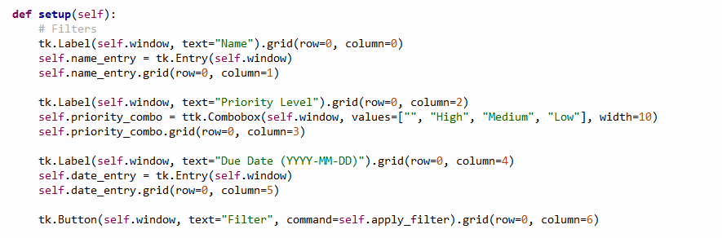

4. Assumptions

- tasks.json will either be generated automatically or be present.
Every task field—name, description, priority, and due date—is present and formatted appropriately.
The due dates are YYYY-MM-DD.
- Tkinter and Python are installed.
Up to 200 tasks should be handled effectively by the GUI.

5. Test Cases for Stage 3
TC 01 Include a task with accurate information
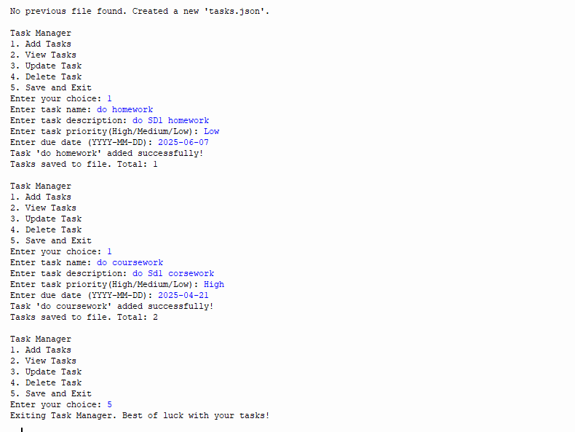
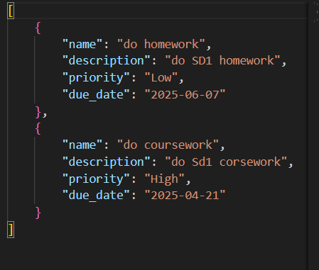

TC 02 Use the current JSON file to launch the program
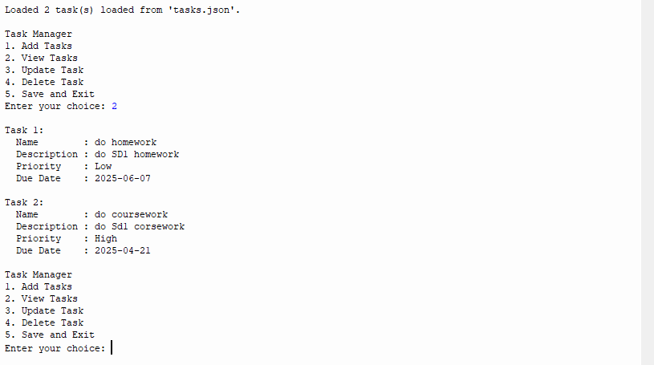

TC 03 Manually corrupt a JSON file

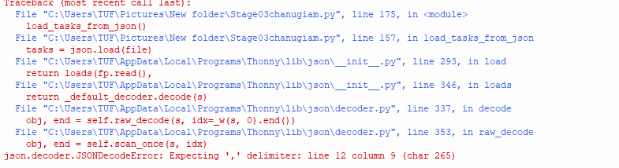

TC 04 Modify an already existing task
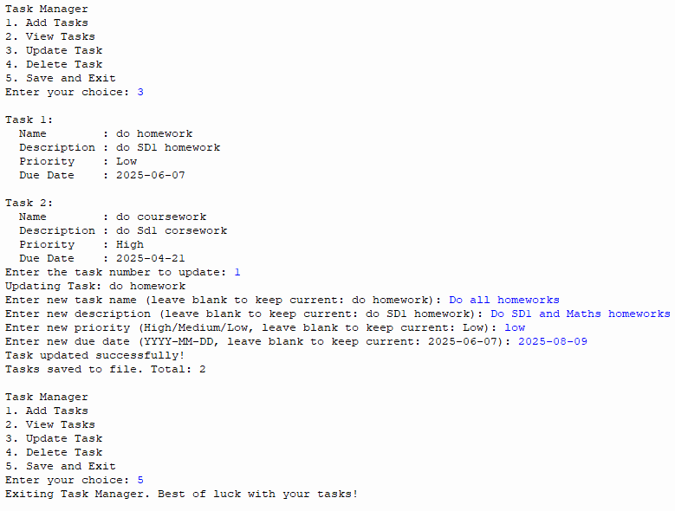
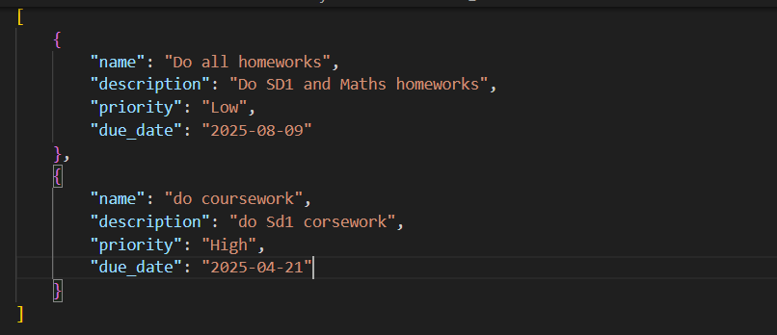

TC 05 Remove a task
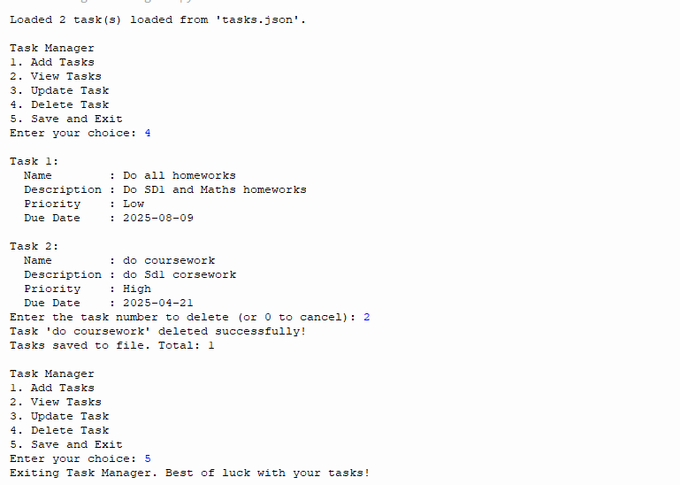
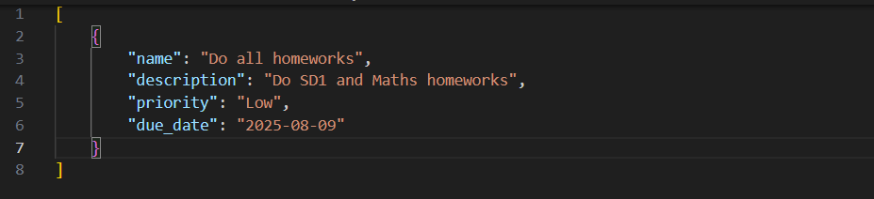

TC 06 Manually edit JSON
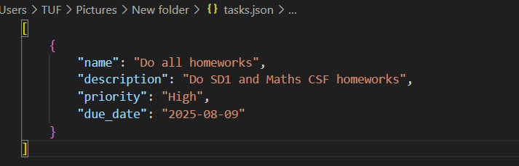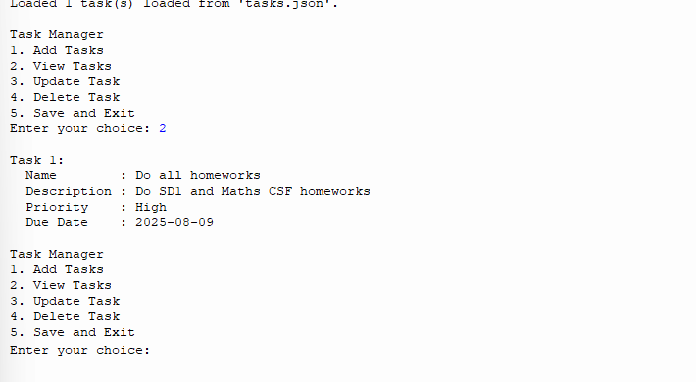

6.Test Cases Results

Summary of Test Cases – Stage 3
Every test case that was created for Stage 3—both edge and regular operations—passed.
Even in situations where data files are corrupted or missing, the application's robustness and validation guarantee consistent performance.

Test Case | User Action | Expected Result | Actual Result
TC 01 | Include a task with accurate information | The task is stored in tasks.JSON | Pass
TC 02 | Use the current JSON file to launch the program | The tasks load properly. | Pass
TC 03 | Manually corrupt a JSON file | File reset, error handled | Pass
TC 04 | Modify an already-existing task | Saved changes | Pass
TC 05 | Remove a task | The task was deleted from the file | Pass
TC 06 | Manually edit JSON | Changes are apparent in the subsequent run | Pass

7.GUI Usage Instructions Stage 4 (Tkinter)
The 'My Task Manager' window opens when the Task Manager's GUI version is launched.
Features include: -
Name Field: Task name search.
Filter by High, Medium, or Low using the Priority Dropdown.
Due Date Field: Use the YYYY-MM-DD format to filter by date.
Filter Button: Use filters.
Treeview Table: Displays tasks as a table.
Column Sorting: To sort, click on the column headers.
By providing visual access to task data, the GUI enhances the user experience.

Main GUI Interface Loaded
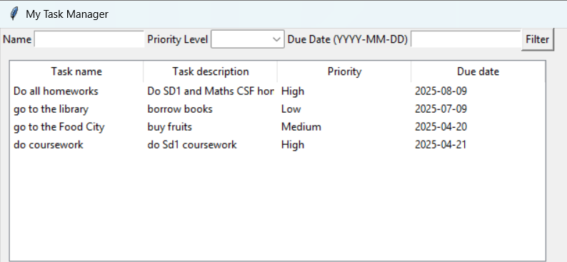
Filtering by Task Name
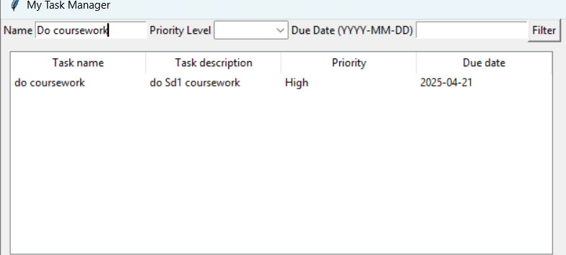
Filtering by Priority
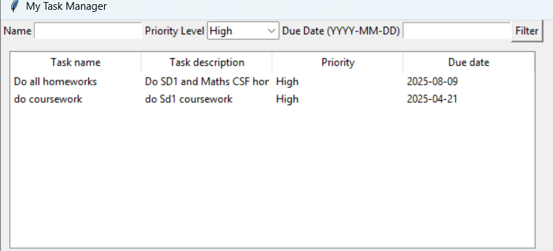

Filtering by Due Date
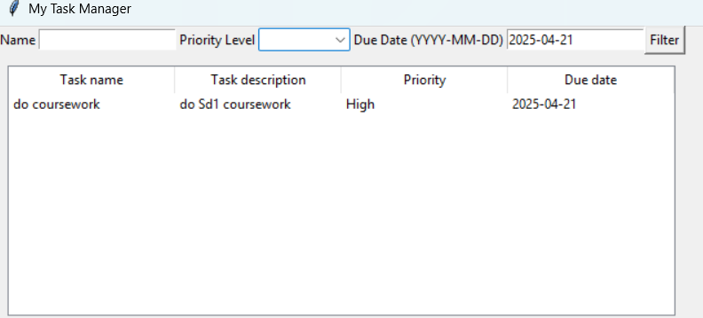

8.LinkedIn Learning Certificate Completion
As part of my professional development for this project, I enrolled in and finished these Linkedln Learning courses.
Course Title | Completion Date | Link
Machine Learning with Python: Foundations | Apr 19, 2025 at 07:26PM UTC | https://www.linkedin.com/learning/certificates/ccc6c8a3a10b0852c464b5aeb7190059b29799b85b94e3d0450accc61e8b87f9?trk=share_certificate
Python Essential Training | Apr 19, 2025 at 05:19PM UTC | https://www.linkedin.com/learning/certificates/1715b41b36373ec69b27e0c92ddb5f442fff5cafb2c30accec8c0ac3d0585205?trk=share_certificate
Python Projects: Create an Interactive Quiz Application | Apr 18, 2025 at 10:57PM UTC | https://www.linkedin.com/learning/certificates/13ba44c34695d58273c52275e9faa96402e97e8122b32cd3168962c52465e616?trk=share_certificate
Python Projects | Apr 18, 2025 at 06:11PM UTC | https://www.linkedin.com/learning/certificates/038289d513f846bec4435350a3f065c27caaad97514d8a17b913bb4876d53753?trk=share_certificate

These course provided a strong foundation in python, focusing on OOP, file I/O handling, and Tkinter GUI programming

Screenshot1   Screenshot 1

9.Conclusion
To illustrate fundamental Python programming abilities, the Task Manager project combines both command-line and graphical user interface development.
While Stage 4 extended the project by incorporating a Tkinter-based interface for task sorting and filtering, Stage 3 focused on using dictionaries for task storage in conjunction with persistent file operations.
Object-oriented programming, input validation, modular architecture, strong exception handling, and an easy-to-use graphical user interface are among the main areas of emphasis throughout the project.

